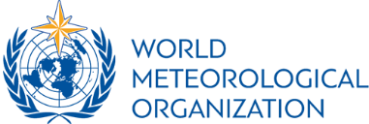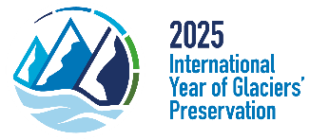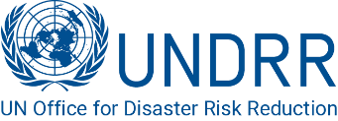

**PRESS-RELEASE**

DUSHANBE – On 30 May 2025 within the High-Level International Conference on Glaciers’ Preservation a special Thematic Session on “Glacial related Hazards and Disaster Risk Reduction: Leveraging the "Early Warnings for All" Initiative” was organized by UNDRR, WMO, and Government of Switzerland.

Glacier-related disasters, like glacial lake outburst floods (GLOFs) and other floods, avalanches, and ice collapses, threaten communities and infrastructure in mountainous regions. Climate change exacerbates these risks by accelerating glacier retreat and increasing meltwater, making the global Early Warnings for All (EW4All) initiative, and more broadly disaster risk reduction (DRR), urgent priorities. This high-level session aimed to address these growing threats and promote global collaboration and solutions that should protect vulnerable populations.

The session discussed the impact of glacier-related hazards/disasters, respective forecasting and warning systems and impact of the hazards downstream, specially focusing on the disproportionate impact on resource-limited regions.

Effective EWSs can reduce loss of life and damage by providing lead time for evacuation and emergency response. Yet, many at-risk areas, especially in developing nations, lack coverage – the gap that the UN’s EW4All initiative aims to close by 2027. Glacier-specific EWSs need real-time data on glacier dynamics and downstream risks as well as non-real-time vulnerability data/risk maps and DEMs., requiring technology and investments that have to be supported by high-level political will and advocacy.

DRR aims at building long-term resilience through measures such as risk knowledge and awareness building, land-use planning, infrastructure reinforcement, and community education. The Sendai Framework underlines the importance of a whole of government and all of society approach to DRR, the priorities for DRR financing, and supports a multi-hazard approach within risk reduction and EWSs, which can be tied to broader climate change adaptation goals.

Mr. Sulaimon Ziyozoda, Tajikistan, Deputy Prime Minister, National DRR Platform Chairman, EW4All National Focal Point highlighted “the importance of strengthening multi-stakeholder partnerships among UN agencies and partners, donors and international financial institutions, governments, academia, civil society, and local communities for improving glacier preservation and DRR and for sustainable funding and accountability under the frameworks of the IYGP 2025, Action Decade of Cryospheric Sciences, and EW4All”.

“We need to strengthen our understanding of the climate–cryosphere–water nexus through an Earth System approach. Free data exchange is key – it all boils down to data.” – mentioned Prof. Celeste Saulo, WMO, Secretary General.

In terms of the Sustainable Development Goals and other global agendas, the session links to the Sendai Framework for DRR 2015-2030 (especially its Global Target G) and SDG 13 (Climate Action) by enhancing EWSs and disaster preparedness, which are essential for climate change adaptation. It also contributes to SDG 11 (Sustainable Cities and Communities) by reducing disaster risks for vulnerable populations and SDG 6 (Clean Water and Sanitation) by ensuring water security in glacier-fed basins.

Participants called for the following actions to be taken in this area:

* Launch public awareness raising that visually and narratively portray the escalating risks of glacier-related hazards, emphasizing localized impacts
* Identify glacier- and other cryosphere-related disaster loss data within national loss and risk assessments, in order to drive evidence-based policy, if possible, in a harmonized way that facilitates international data exchanges and comparisons.
* Enhance national risk governance mechanisms by inclusion of glacier hazard expertise and the integration of monitoring into risk management strategies
* Utilize the EW4All framework to foster broader engagement of governments and stakeholders in addressing glacier-related hazards, ensuring that EWS are duly prioritized and effectively reach vulnerable communities
* Support developing transboundary EWS withing the EW4All at the sub-regional level, prioritizing the collaborative monitoring and dissemination of alerts for glacier-related hazards
* Initiate a collaborative, multi-stakeholder effort to produce comprehensive glob-al/regional project proposals, outlining actionable strategies and plans for glacier hazard DRR

**Contact persons:**

Sulagna Mishra, WMO, [smishra@wmo.int](mailto:smishra@wmo.int)

Dilshod Kodirov, UNDRR, [dilshod.kodirov@un.org](mailto:dilshod.kodirov@un.org)

Dr. Ali Neumann, SDC, [ali.neumann@eda.admin.ch](mailto:ali.neumann@eda.admin.ch)