FAO opened a new warehouse for the storage of obsolete pesticides in Vakhsh district
(08/04/2023)
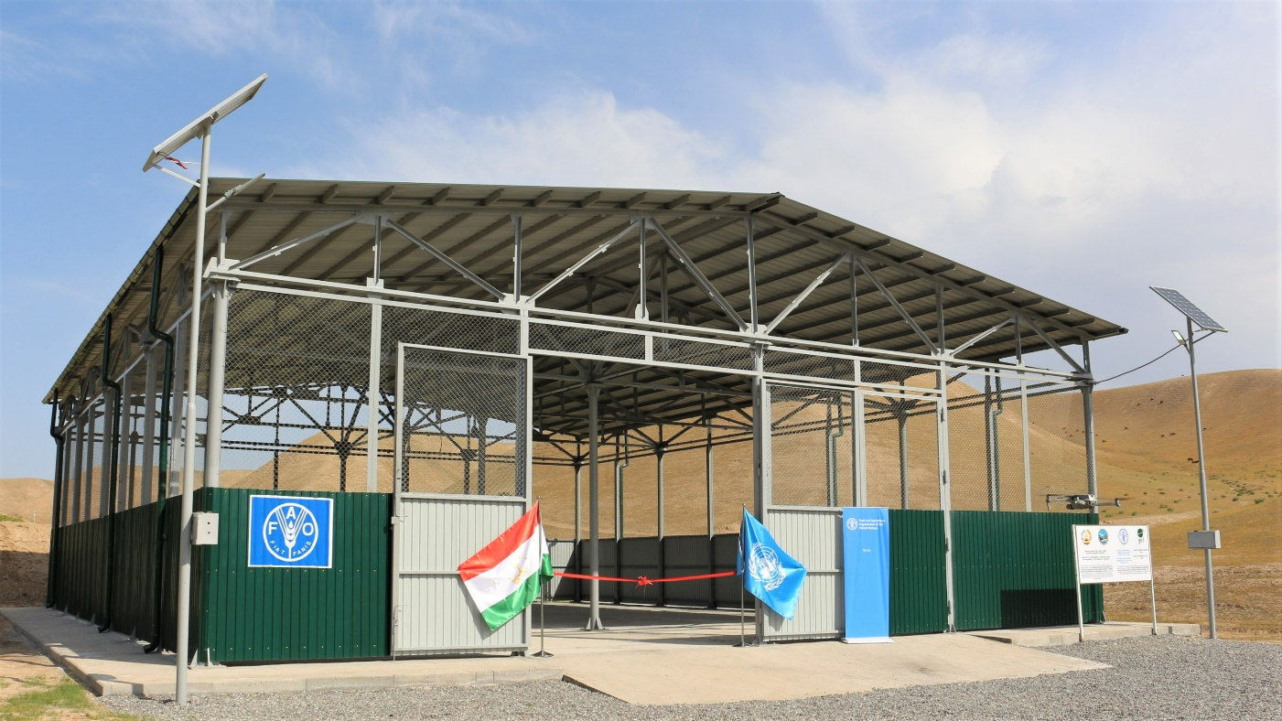
©FAO. FAO/GEF supported warehouse for the storage of obsolete pesticides in Vakhsh district

In Tajikistan, there are around 200 mini-landfills where obsolete pesticides are buried near residential areas. Most of these pesticides are persistent organic pollutants (POPs), which are chemicals that persist in the environment and remain harmful for a long time. These toxic chemicals are often stored outdoors in leaky containers or buried in shallow trenches. It leads to further seeping into soil and water, harming the environment pose an extreme risk to public health.
FAO works to prevent the build-up of new obsolete stocks by introducing better agricultural practices, enhancing sustainability and resilience, reducing reliance on pesticide and ensuring better management of pesticides. The project also works on improvement of the governance of the obsolete pesticides and, jointly with farmers, demonstrates and promotes alternatives to highly hazardous pesticides through Integrated Pest Management (IPM) practices.

On 8 April 2022, the Food and Agriculture Organization of the United Nations (FAO) and the Committee for Environmental Protection under the Government of the Republic of Tajikistan (CEP) officially opened a new warehouse for the storage of obsolete pesticides. The store annex was built in a framework of the GEF/FAO project "Lifecycle Management of Pesticides and Disposal of POPs Pesticides in Central Asian countries and Türkiye".
The project aims to reduce POPs releases from obsolete pesticide stockpiles and contaminated sites, as well as strengthen the capacity for the proper management of pesticides. To achieve this, FAO has been working in close collaboration with the CEP to improve infrastructure at the Vakhsh obsolete pesticides landfill, including the construction of a store annex with a capacity to store up to 1000 tons of obsolete pesticides.
This marks an important milestone in the ongoing effort to address Tajikistan's environmental challenges related to obsolete pesticide and contaminated site management.
The main purpose of the store annex is to enlarge the temporary storage space available for obsolete pesticides and soils contaminated with high concentrations of pesticides. This will enable the remediation of various mini-landfills in the Khatlon region over the coming years.
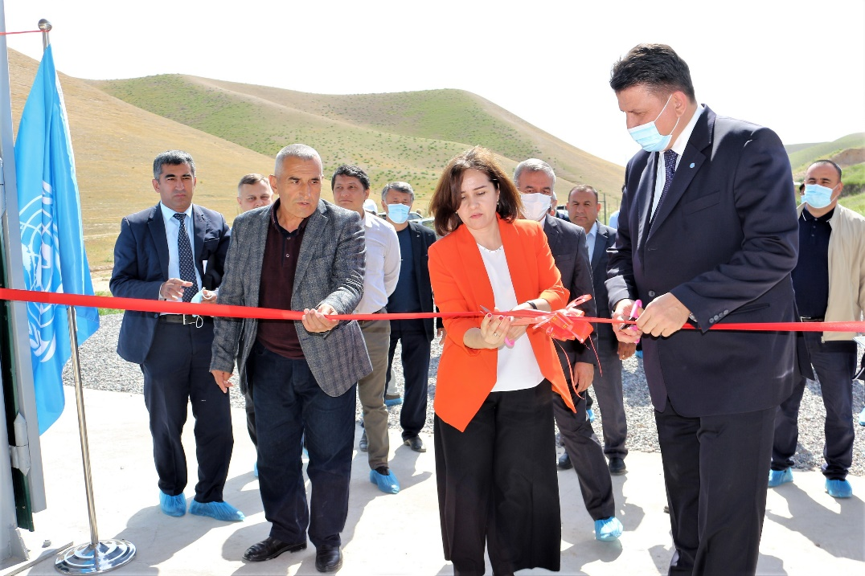
©FAO. Ms. Kiemzoda, Deputy Chairman of CEP and Mr. Guchgeldiyev, FAO Representative officially opening a warehouse

"Under this initiative, FAO office in Tajikistan contributes to the better management of obsolete chemicals, as well as demonstrates the best practices in producing food with less chemicals. The recovery efforts will help to demonstrate how numerous abandoned landfills and areas around them can be returned to the safe and sustainable production in Tajikistan”, mentioned Oleg Guchgeldiyev, FAO Representative in Tajikistan. “Besides improvement of the livelihoods of people living in these areas, the improved pesticide management will have positive impact on environment, on conservation of the precious water resources and contributes to the fulfilment of country’s obligations under various international conventions”, he added.
To pilot remediation process, the project will start the transportation of the obsolete pesticides from the mini-landfills in Pyanj jamoat, Jayhun district of Khatlon region. Within the remediation work, 409 tons of POPs pesticides and 4769 tons of contaminated soil will be securely transported and stored in Vakhsh special landfill. The work is planned to be completed by the end of 2023.
Opening the store annex at the Vakhsh landfill is a significant step forward in addressing Tajikistan's environmental challenges related to obsolete pesticide management. FAO will continue to work closely with the government of Tajikistan to support the pesticide management and remediation of contaminated sites
SDGs 12, 15

