DUSHANBE, TAJIKISTAN – June 30, 2021

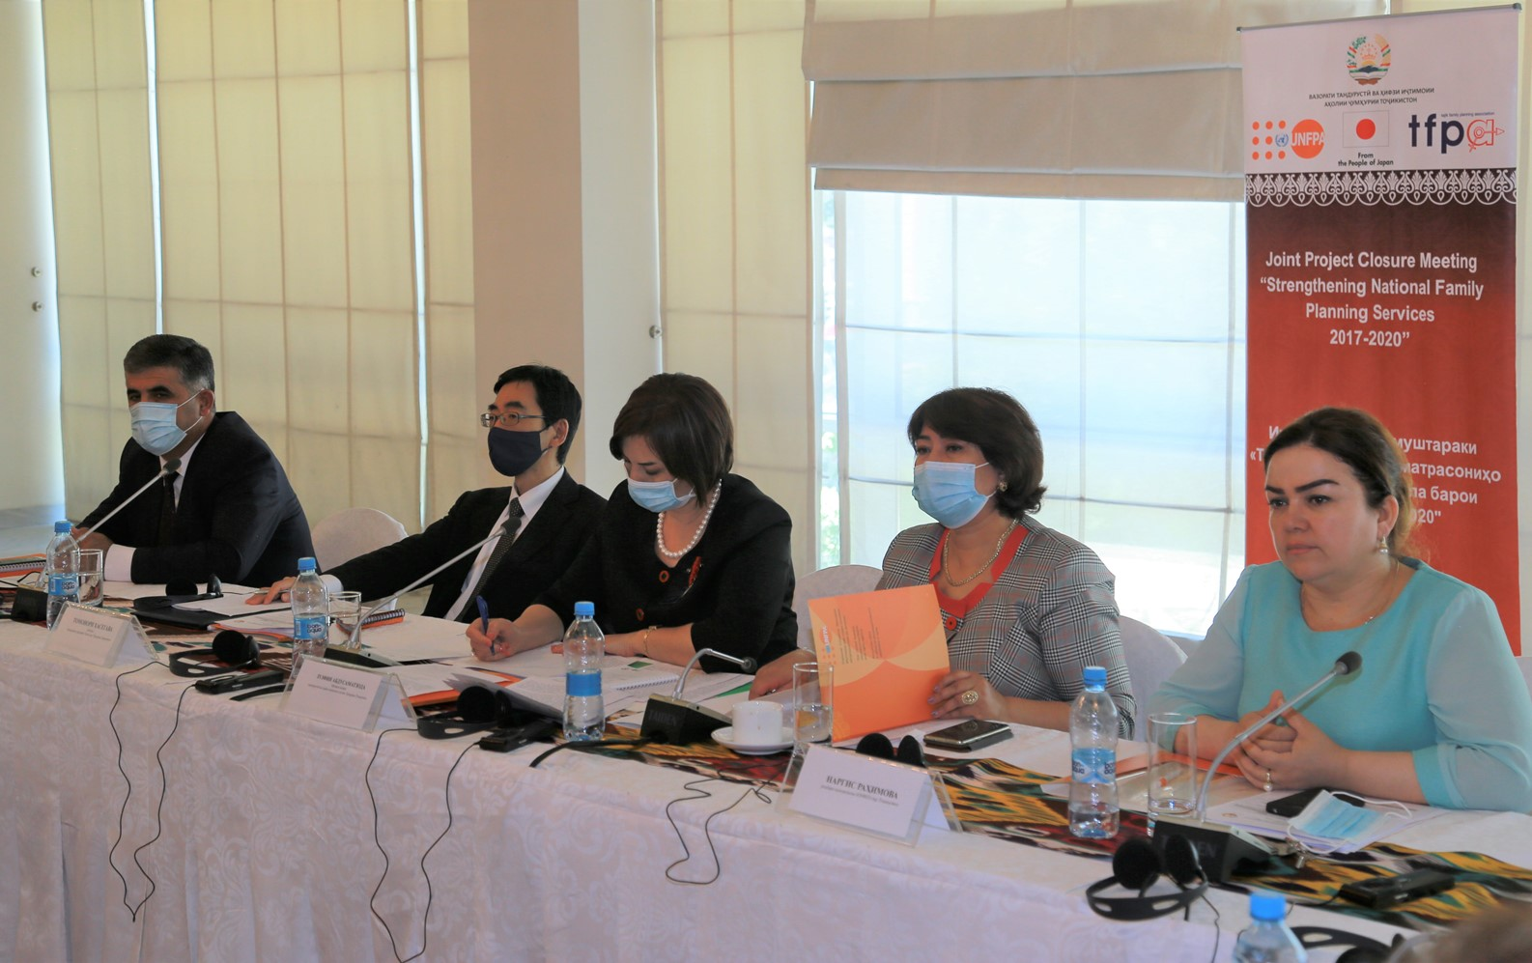
Official Project Closure - Strengthening National Family Planning Services 2017-2020 conducted in Dushanbe

June 30, 2021 the United Nations Population Fund (UNFPA) in Tajikistan and the Tajik Family Planning Association through the support of the Ministry of Health and Social Protection of the Population of the Republic of Tajikistan hold the official joint meeting to project closure - “Strengthening National Family Planning Services 2017-2020”.

During the meeting, UNFPA Tajikistan presented the final report on implementation of the Joint Project on Strengthening National Family Planning services (2017-2020): Achievements, Challenges & Future Perspectives. The meeting was attended by Ms. Zulfiya Abdusamatzoda, Deputy Minister of Health and Social Protection of the Population, Mr. Tomonori HASEGAWA, Chargé d’ Affaires ad interim of the Embassy of Japan in Tajikistan, Ms. Nargis Rakhimova, Head of UNFPA Country Office in Tajikistan, representatives of other ministries and line agencies, representatives of health structures, regional health departments and reproductive health centers, as well as representatives of International Organizations and CSOs.

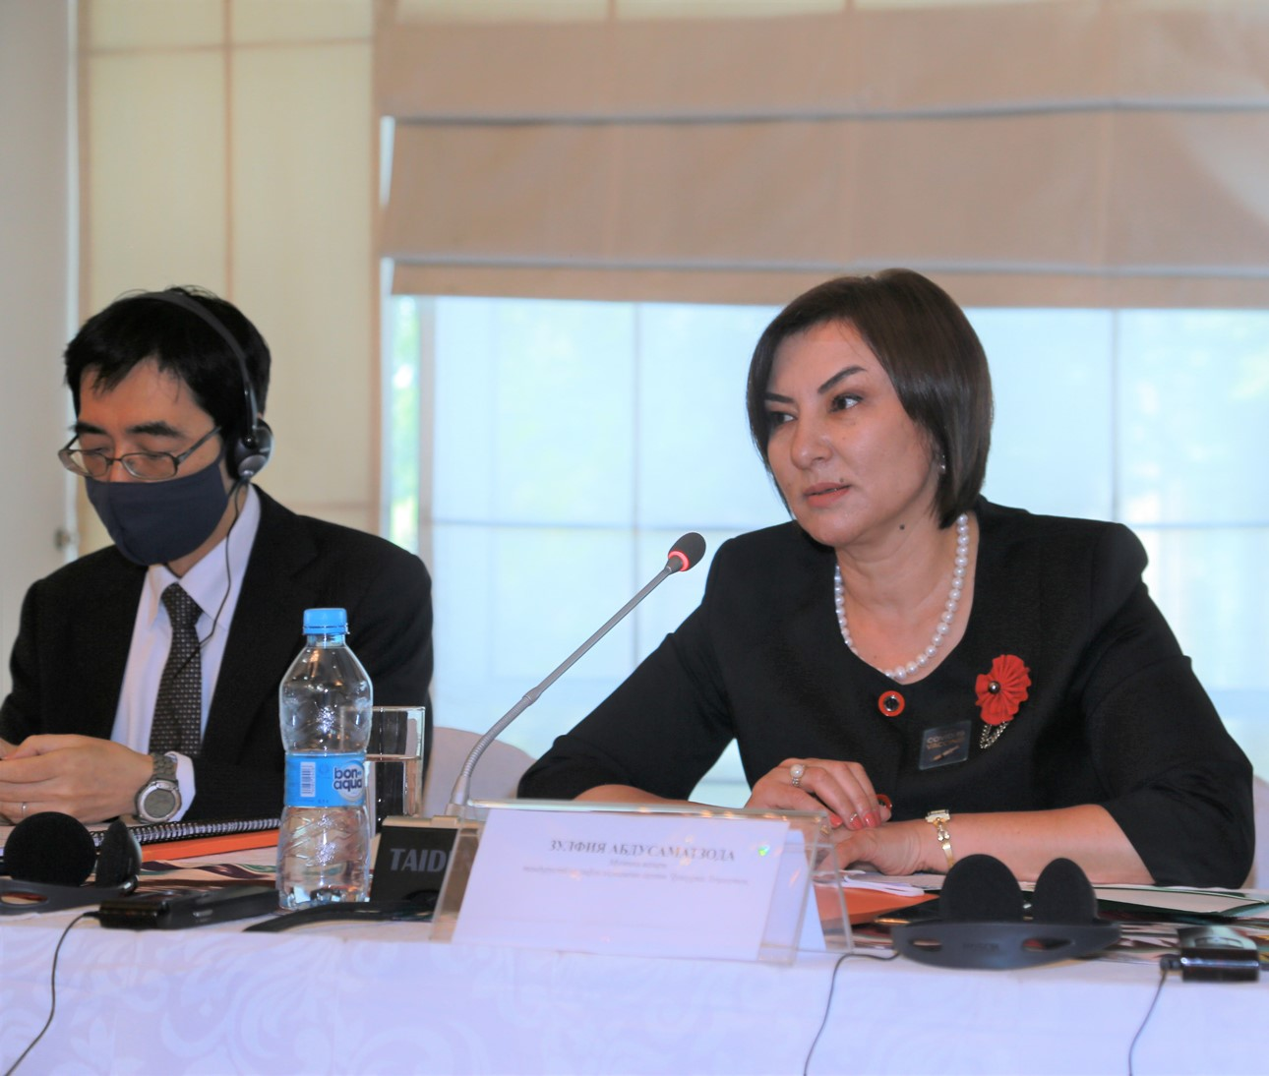
In her opening speech Ms. Zulfiya Abdusamatzoda, Deputy Minister of Health and Social Protection of the Population mentioned: “Dear participants, it should be noted that on March 9, 2017 the United Nations Population Fund (UNFPA) in Tajikistan, the Embassy of Japan in Tajikistan and the Government of Tajikistan approved the joint Project on Strengthening National Family Planning Services 2017-2020. Through joint efforts of the Government of Tajikistan, Government of Japan and UNFPA we worked on strengthening the family planning issues through sustainable provision of contraceptive means, expanding the knowledge and opportunities of family planning service providers in remote areas of the country and expanding the public access to modern family planning services”.
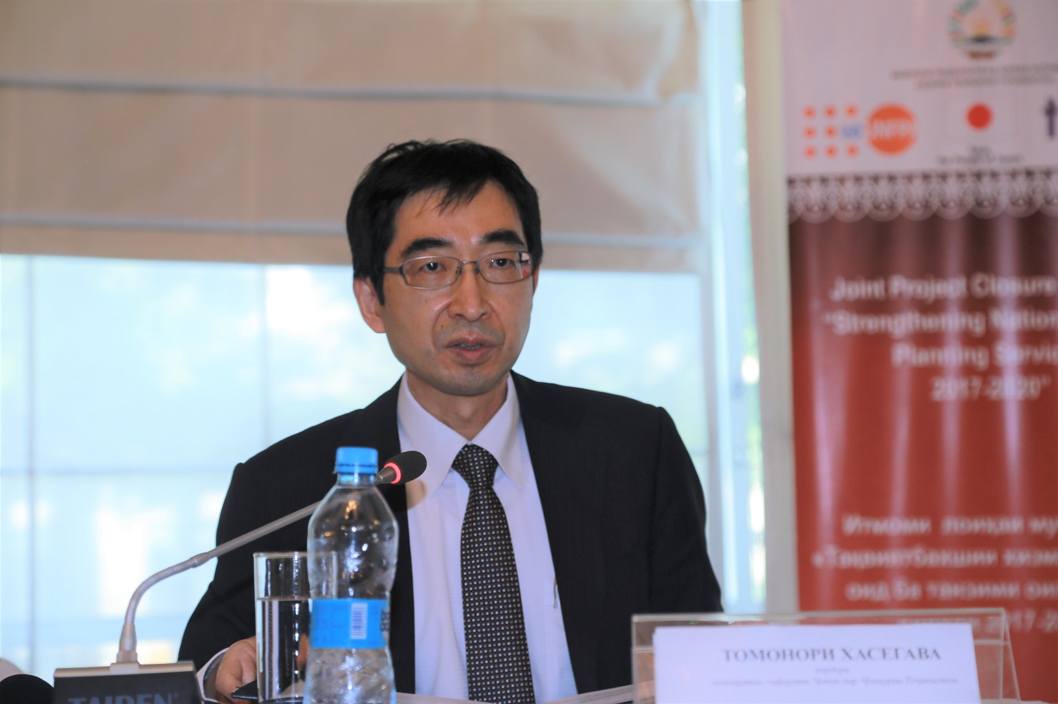
Mr. Tomonori HASEGAWA also noted that family planning is one of the essential public health services aimed at reducing maternal and infant mortality and expressed the hope that, in cooperation with the Government of the Republic of Tajikistan and Development Partners, the health of mothers and children will further improve. In addition, in his final feedback, Mr. Tomonori HASEGAWA mentioned: "I am convinced of the great results the Joint Project achieved through financial support provided by the Government of Japan. I will share the new project proposal with my headquarters".

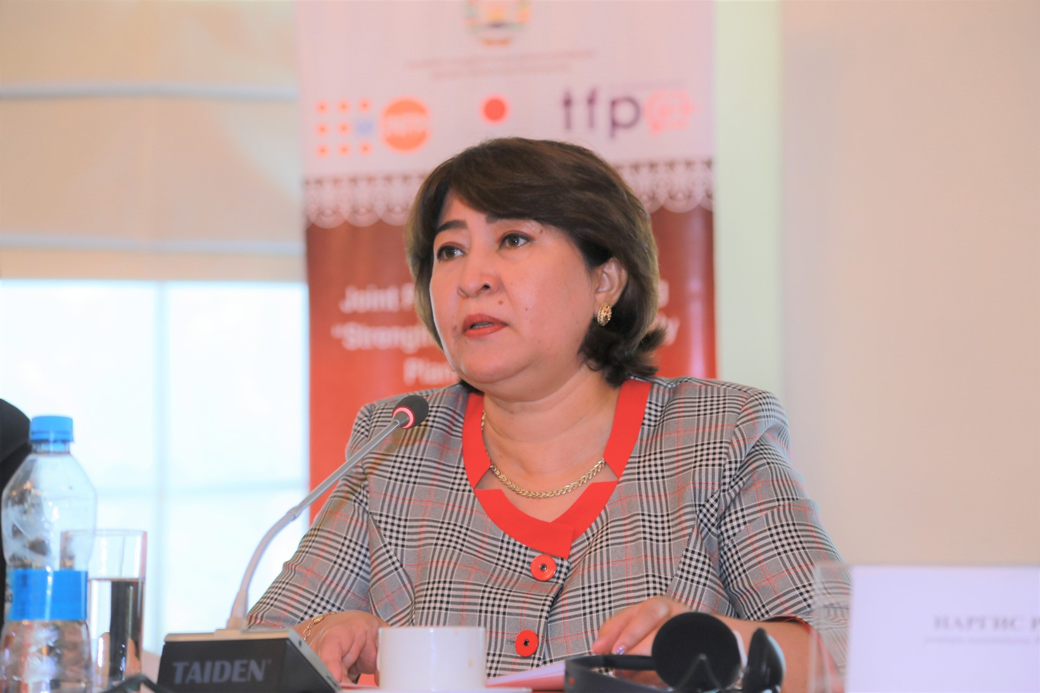
Ms. Nargis Rakhimova, Head of UNFPA Country Office in Tajikistan mentioned: “The FP program around the world depends on the availability of modern methods of contraception, which is a prerequisite for any FP service. The first goal of the joint project was to ensure the supply and availability of modern contraceptive methods at all levels. UNFPA, in cooperation with the MoHSPP of Tajikistan completed the procurement of contraceptives based on a multi-year procurement forecast. Moreover, with the support of the Government of Japan and in order to expand the choice of the population in contraception, new types of contraception were purchased, including subcutaneous implants, injectable and oral methods of contraception and the number of contraceptives were increased from 5 to 8 types.”

Project results and achievements: Сontribution of the Government of Tajikistan for the procurement of contraceptives increased from $20,000 in 2017 to $90,000 in 2020. The State RH Programme for 2019-2022 is developed and under implementation. Five types of contraception purchased according to the country's annual requirement. Three new types of contraception purchased in 2020, such as injectable, oral and subcutaneous. 110 midwives from the most remote Health Houses of Khatlon, Sughd regions and Districts of Republican Subordination certified in provision of quality IUD insertion and removal services and provided with insertion and removal kits. To date, more than 5000 successful IUD insertions/removal registered by RH services. 953297 family planning users have access to the currently available five modern methods of contraception. The increase in the number of more than 50,000 new users confirmed by the MoHSPP statistics.

* * *
The United Nations Population Fund (UNFPA) delivering a world where every pregnancy is
wanted, every childbirth is safe and every young person’s potential is fulfilled

