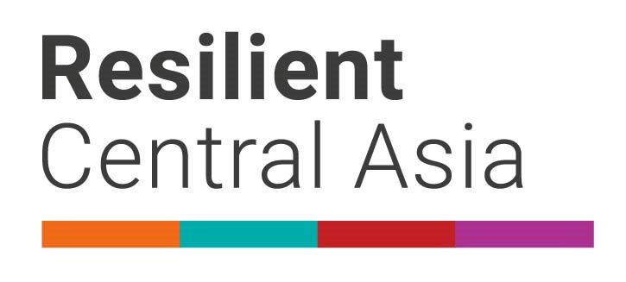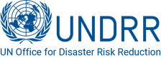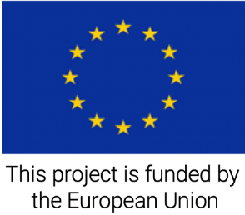

**PRESS RELEASE**

**Central Asia countries strengthen coordination in disaster risk reduction**

**Bishkek, 11 December 2020** - Today, in the frame of the European Union funded Program “Strengthening disaster resilience and accelerating implementation of Sendai Framework for Disaster Risk Reduction in Central Asia”, implemented by the United Nations Office for Disaster Risk Reduction (UNDRR), the Center for Emergency Situations and Disaster Risk Reduction (CESDRR) organized the Forum – Consultative Meeting of heads of national emergency management agencies (NDMAs) of the countries of Central Asia.

In the annual meeting, the delegations of the countries analyzed the implementation of the Action Plan (Roadmap) for the implementation of the Framework for strengthening regional cooperation of Central Asian countries in the field of DRR and emergency situations in 2019-2021 adopted by the 2019 Regional Forum - Meeting of Heads of NDMAs. The national delegations reiterated the importance of preparedness for the new emerging threats such as the ongoing COVID-19 pandemic and reiterated the value of exchange of information and experience in building capacity for reducing the possible losses.

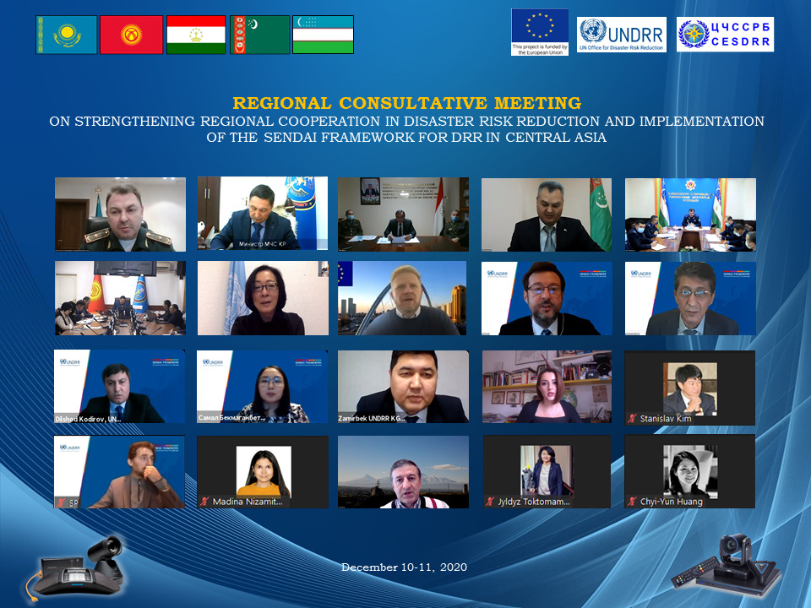The program of the Forum included presentation of the first draft of the Regional Strategy for Disaster Risk Reduction, developed by CESDRR within the EU-funded Initiative. The strategy, aiming at reducing risk of cross-border scale and nature, calls for better exchange of information, joint risk assessment, building capacity of emergency management organizations, raising awareness of the existing and possible new hazards.

“We realize the importance of resilience at all levels, the importance of a strategy for regional cooperation, because not a single country can protect its population all by itself from the pandemic or from other threats”, stated Boobek Azhikeyev, Minister of Emergency Situations of Kyrgyz Republic.

“It is inspiring to see how Central Asia countries come together to share experiences, lessons learned and good practices. Just recently, in September this year, all five countries met to share experience and to coordinate actions for overcoming the COVID-19, together with international organizations. The work of the CESDRR is another concrete example of these critical efforts’, said Mr. Octavian Bivol Chief Regional Office for Europe, UNDRR. “Next year is an important one for Member States for developing a resilient, green recovery from the COVID-19 pandemic, strengthening risk reduction initiatives, and improving governance. Disaster risk reduction is an investment to ensure that “never again” will we suffer such devastating consequences, whether from a biological hazard like COVID-19 or climate change.

“Strengthening resilience to potential natural disasters at all levels, from community to governments, has been an essential part of European Union’s disaster risk reduction efforts in Central Asia. Since 2003, European Commission’s Humanitarian Aid and Civil Protection department (ECHO) has continuously implemented activities under its disaster preparedness program known as DIPECHO. Over the years, with a total of approximately 47 mln Euro and more than 110 projects, DIPECHO managed to promote DRR in Central Asian countries.”  - said Johannes Madsen, Head of Cooperation in Central Asia.

The Regional Forum adopted the outcome document, resolving to: acknowledge the information on the activities in disaster risk reduction in the region; further consolidate and enhance regional coordination; review the draft Regional Strategy for Disaster Risk Reduction for 2022 – 2030 and the draft Regional Risk Profile and contribute in their finalization. Central Asian states expressed willingness to work together in order to strengthen risk reduction governance and to reduce existing and future risks.

The Regional Forum brought together National Emergency Management Organizations, Sendai Focal Points, international organizations working in the area of emergency response and risk reduction, representatives of the European Union and UN system organizations.

**Background information**

The EU funded project “Strengthening disaster resilience and accelerating implementation of Sendai Framework for Disaster Risk Reduction in Central Asia”, implemented by the United Nations Office for Disaster Risk Reduction (UNDRR), aims to support countries of the region in implementing Sendai Framework priorities. The project supports strengthening regional coordination, including development of regional DRR strategy, regional data loss database, and enhancing the role of CESDRR as the center of excellence, the secretariat of regional platform for DRR, and a hub for regional coordination. The support on national level includes assistance in developing/adjusting national DRR strategies, disaster loss database, and establishment of national platforms for DRR. On the local level, the project will support assessment of resilience of major cities to disasters. For this project the EU committed EURO 3,750,000 for the three yeas implementation.

*For additional information please contact*

*Ms. Gulnara Dussupova Programme Officer, Delegation of the European Union to the Republic of Kazakhstan, at:* [*gulnara.dussupova@eeas.europa.eu*](mailto:gulnara.dussupova@eeas.europa.eu%20)

*Mr. Abdurahim Muhidov, UNDRR Regional Programme Coordinator, email:* [*muhidov@un.org*](mailto:muhidov@un.org)