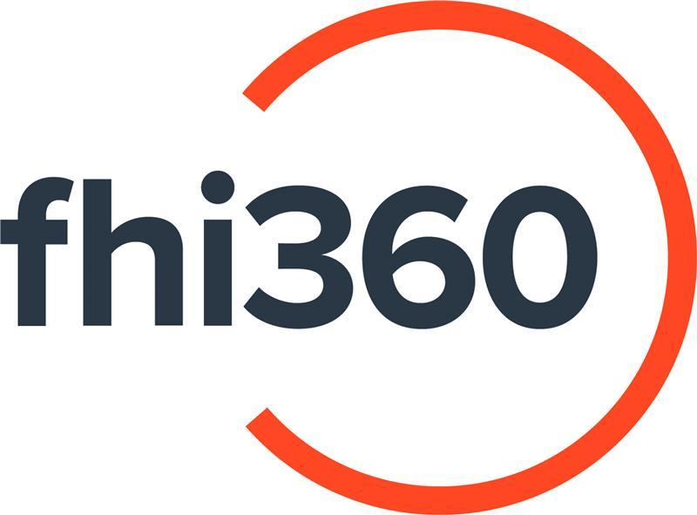

REQUEST FOR QUOTATION
Simulteneous Translation Services
Branch of Family Health International (FHI360) in Tajikistan

RFQ #: TB-24-023
Issue Date: September 30, 2024
Response Deadline: October 13, 2024

Background:

FHI 360 is a global organization that mobilizes research, resources, and relationships so people everywhere have access to the opportunities they need to lead full and healthy lives. With collaborations in over 60 countries, we work directly with local leaders to advance social and economic equity, improve health and well-being, respond to humanitarian crises, and strengthen community resilience. We share data-driven insights and scalable tools that expand access and equity so communities can effectively address complex challenges, respond to shocks, and achieve thriving futures.
The Branch of Family Health International (FHI 360) in the Republic of Tajikistan is a separate structural unit of Family Health International (FHI 360), a non-profit organization created and operating in accordance with the laws of the state of North Carolina, USA, with a project office in Dushanbe, Republic Tajikistan.
The main goal and objective of FHI 360 is to, by representing the interests of the Organization in the Republic of Tajikistan, promote the creation of innovative solutions in the social and economic spheres, as well as in the development, implementation and promotion of health activities on a long-term basis through the development of comprehensive solutions. This work to address the challenges of integrated development will be carried out in partnership with various government and non-government agencies, non-profit organizations and other organizations, including companies or corporations.

Purpose of the assignment:
The Branch of Family Health International (FHI 360) in Tajikistan intends to enter into Master Service Agreement (MSA) with successful vendor based in Dushanbe, Kulob, Bokhtar and Khujand cities for the purpose of provision of Simultaneous translation services for one year with possible extension for up to 2 years based on performance of the MSA holders.

The service provider will be requested to provide simultaneous interpretation services during project events (ceremonies, workshops, trainings, conferences, informative community events, etc.) and meetings (technical working groups meetings, meetings between international advisors/experts or FHI360 representatives and local
counterparts, etc.).
The service provide shall deliver translation services for the below listed language pairs:
  - English – Tajik
  - English - Russian
  - Tajik – English
  - Tajik- Russian
  - Russian – English
  - Russian – Tajik

General requirements for the provision of services:
- Simultaneous Interpreting (visits to project sites, in-person meetings and trainings, online webinars, conference calls, etc.);
- Deliver high-quality translation services.

Minimum qualification requirements:
- Individuals, officially registered Companies or Private Entrepreneurs legally operating on the territory of the Republic of Tajikistan.
- At least 5 years of experience in simultaneous translation and interpretation services;
- Education in relevant fields (translation and interpreting, literature, and any other relevant department);
- Experience in the knowledge of medical terms, particularly related to TB, HIV/AIDS, COVID-19 and others;
- At least 4 years of working experience with international organizations.
- Availability of at least 2 contact information and/or recommendation letters on completion of similar activities stipulated in this RFQ.

List of required documents for submission:

For companies and private entrepreneurs:
- Documents confirming the official registration of a legal entity or private entrepreneur operating on the territory of the Republic of Tajikistan.
- The list of translators and interpreters and their CVs must be provided as per the requirements of this RFQ.
- At least 2 contact information and/or recommendation letters on completion of similar activities stipulated in this RFQ.
- Financial Proposal as per tables below in Tajik somoni excluding VAT and valid for 1 year.
For individuals:
- CV must be provided.
- At least 2 contact information and/or recommendation letters on completion of similar activities stipulated in this RFQ.
- Financial Proposal (as per table below) in Tajik Somoni including all applicable taxes (15% and 2%) and valid for 1 year.
Template of Financial Proposal:
Language pair | For individuals |  | For companies
 | Price per half day (4 hours) in Somoni including taxes (15% income tax + 2% pension fund) | Price per day (8 hours) in Somoni including taxes (15% income tax + 2% pension fund) | Price per half day (4 hours) in Somoni excluding VAT | Price per day (8 hours) in Somoni excluding VAT
English – Tajik
English – Russian
Tajik – English
Tajik – Russian
Russian – English
Russian - Tajik

Evaluation criteria, weightage and process:

Screening stage. Review all submitted proposals to ensure they meet the minimum requirements/eligibility criteria. Only shortlisted bidders will advance to the evaluation stage.

First evaluation stage. Technical evaluation – max 30 points. Passing score for further stage – 24 points.
Quotations will be technically evaluated based on the following criteria:
- Experience in simultaneous translation services – 10 points
- Working experience with international organizations – 10 points
- Experience and skills in translating medical terminology, especially for conditions such as TB, HIV/AIDS, COVID-19, and others – 10 points
Bidders getting minimum 24 points out of 30 points in this stage will advance to further evaluation stage.
Second evaluation stage. Testing of Translation Quality, Skills, and Knowledge – 40 points.
Bidders will be invited to undergo the test.

Final evaluation stage. Financial evaluation – 30 points

The procedure for payment:
Payments shall be made monthly in Tajik Somoni within 30 days upon successful completion of the tasks, submission of all necessary documents, and invoices/payment requests together with all supporting documents.

Submission Guidelines:
- Responses to this RFQ should be submitted by email to procurement.TB.TJ@fhi360.org with subject “RFQ Translation services” in subject line.
- Clarificatory questions are due to October 13, 2024.
- Offers must be received no later than October 13, 2024, 18:00 TJT.
- Offers should be valid for 60 (sixty) days from the date of submission.
- Offers received after this date and time may not be accepted and shall be considered non-responsive.
- Offers that do not meet the requirements of this RFQ will not be considered.

RESERVED RIGHTS
All submitted proposals become the property of FHI 360, which discloses the right, at its own discretion:
- To disqualify any offer based on offeror failure to follow solicitation instructions.
- Extend the time for submission of all RFQ responses after notification to all offerors.
- Award only part of the activities in the solicitation or issue multiple awards based on solicitation activities.
- FHI 360 will not compensate vendors for preparation of their response to this RFQ.
- Issuing this RFQ is not a guarantee that FHI 360 will award a Master Service Agreement.
- FHI 360 shall not be obligated to order any minimum or maximum quantities of services or products and assumes no commitment, financial or otherwise.

