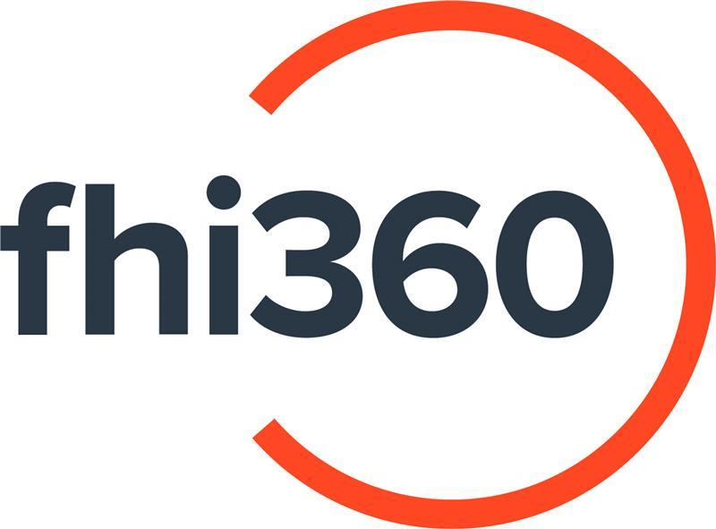

REQUEST FOR QUOTATION
Translation and Interpretation Services
Branch of Family Health International (FHI360) in Tajikistan

RFQ #: TB-24-017
Issue Date: July 22, 2024
Response Deadline: July 31, 2024

Background:

FHI 360 is a global organization that mobilizes research, resources, and relationships so people everywhere have access to the opportunities they need to lead full and healthy lives. With collaborations in over 60 countries, we work directly with local leaders to advance social and economic equity, improve health and well-being, respond to humanitarian crises, and strengthen community resilience. We share data-driven insights and scalable tools that expand access and equity so communities can effectively address complex challenges, respond to shocks, and achieve thriving futures.
The Branch of Family Health International (FHI 360) in the Republic of Tajikistan is a separate structural unit of Family Health International (FHI 360), a non-profit organization created and operating in accordance with the laws of the state of North Carolina, USA, with a project office in Dushanbe, Republic Tajikistan.
The main goal and objective of FHI 360 is to, by representing the interests of the Organization in the Republic of Tajikistan, promote the creation of innovative solutions in the social and economic spheres, as well as in the development, implementation and promotion of health activities on a long-term basis through the development of comprehensive solutions. This work to address the challenges of integrated development will be carried out in partnership with various government and non-government agencies, non-profit organizations and other organizations, including companies or corporations.

Purpose of the assignment:
The Branch of Family Health International (FHI 360) in Tajikistan intends to enter into Master Service Agreement (MSA) with successful vendors based in Dushanbe, Kulob, Bokhtar and Khujand cities for the purpose of providing Complex Multilingual Translation and Interpreting Services for one year with possible extension for up to 2 years based on performance of the MSA holders.

Note: Vendors have flexibility to apply for one LOT, several LOTs, or all LOTs in this Request for Quotation. Kindly specify your preference in your submission.

The required language pairs for written translation and interpreting works (consecutive and simultaneous) are as follows:
  - English – Tajik
  - English - Russian
  - Tajik – English
  - Tajik- Russian
  - Russian – English
  - Russian – Tajik
  - Uzbek – (into Tajik, Russian, English and vice versa)
General requirements for the provision of services:
- Consecutive Interpreting (in-person meetings and trainings, online webinars, conference calls, etc.);
- Simultaneous Interpreting (in-person meetings and trainings, online webinars, conference calls, etc.);
- Written Translation (official documents, reports, presentations, communication materials, etc.);
- Delivery of the translation in the Customer’s original format (PDF Power Point, Excel, etc.);
- Quality check and proofreading of translation ensuring no typographical errors in the final text;
- Ensure timely delivery of translated materials;
- Make necessary corrections or changes required by FHI360 and re-submit corrected text within the agreed timeframe;

Minimum qualification requirements:
- Individuals, officially registered Companies and Private Entrepreneurs legally operating on the territory of the Republic of Tajikistan.
- At least 5 years of experience in translation and interpretation services;
- Education in relevant fields (translation and interpreting, literature, and any other relevant department);
- Experience in working with medical terms related to TB, HIV, AIDS, COVID-19 and others;
- Experience in working with international organizations is required;
- Availability of at least 2 contact information and/or recommendation letters on completion of similar activities stipulated in this RFQ.

List of required documents for submission:
For companies and private entrepreneurs:
- Documents confirming the official registration of a legal entity or private entrepreneur operating on the territory of the Republic of Tajikistan.
- The list of translators and interpreters and their CVs must be provided as per the requirements of this RFQ.
- At least 2 contact information and/or recommendation letters on completion of similar activities stipulated in this RFQ.
- Financial Proposal as per tables below in Tajik somoni excluding and including VAT and valid for 1 year.
Note: Vendors have flexibility to apply for one LOT, several LOTs, or all LOTs in this Request for Quotation. Kindly specify your preference in your submission.
For individuals:
- CV must be provided;
- At least 2 contact information and/or recommendation letters on completion of similar activities stipulated in this RFQ.
- Financial Proposal as per tables below in Tajik somoni including all applicable taxes (15% and 2%) and valid for 1 year.
Note: Vendors have flexibility to apply for one LOT, several LOTs, or all LOTs in this Request for Quotation. Kindly specify your preference in your submission.

LOT #1 Written translations
Language pair | Price per page  (1800 characters with spaces) in somoni excluding taxes | Price per page  (1800 characters with spaces) in somoni including taxes | Time for completion/ days
LOT #2 Oral consecutive interpreting based in Dushanbe, Kulob, Bokhtar and Khujand cities (please specify your duty station)
Language pair | Price per half a day (4 hours) in somoni excluding taxes | Price per half a day (4 hours) in somoni including taxes | Price per day (8 hours) in somoni excluding taxes | Price per day (8 hours) in somoni including taxes
LOT #3 Oral simultaneous translation based in Dushanbe, Kulob, Bokhtar and Khujand cities (please specify your duty station)
Language pair | Price per half a day (4 hours) in somoni excluding taxes | Price per half a day (4 hours) in somoni including taxes | Price per day (8 hours) in somoni excluding taxes | Price per day (8 hours) in somoni including taxes
Submission Guidelines:
- Responses to this RFQ should be submitted by email to procurement.TB.TJ@fhi360.org with subject “RFQ Translation services” in subject line.
- Clarificatory questions are due to July 30, 2024.
- Offers must be received no later than July 31, 2024, 17:00 TJT.
- Offers should be valid for 50 (fifty) days from the date of submission.
- Offers received after this date and time may not be accepted and shall be considered non-responsive.
- Offers that do not meet all the requirements of this RFQ will not be considered.

Award criteria and weightage:
Quotations will be evaluated based on the following criteria:
- Experience in translation services (30%)
- Experience with international organizations (10%)
- Experience working with medical projects: TB, HIV, AIDS, COVID-19 and others (20%)
- Financial Proposal (40%)
The second stage of the procurement process with the shortlisted vendors will include translation of the 1-page document to determine the quality of written translation and understanding of medical terms.

The procedure for payment:
Payments shall be made monthly in Tajik Somoni within 30 days upon successful completion of the tasks, submission of all necessary documents, and invoices/payment requests together with all supporting documents.

RESERVED RIGHTS
All submitted proposals become the property of FHI 360, which discloses the right, at its own discretion:
- To disqualify any offer based on offeror failure to follow solicitation instructions.
- Extend the time for submission of all RFQ responses after notification to all offerors.
- Award only part of the activities in the solicitation or issue multiple awards based on solicitation activities.
- FHI 360 will not compensate vendors for preparation of their response to this RFQ.
- Issuing this RFQ is not a guarantee that FHI 360 will award a Master Service Agreement.
- FHI 360 shall not be obligated to order any minimum or maximum quantities of services or products and assumes no commitment, financial or otherwise.

