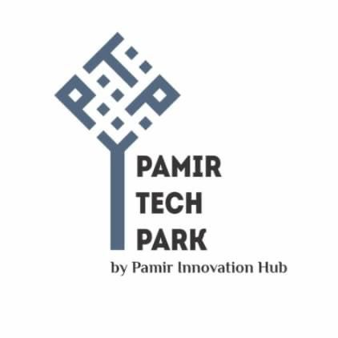

**Job Title:** Project Manager

**Job Type:** Full-time, Contract

**Location:** Khorog, Gorno-Badakhshan Autonomous Region (GBAO), Tajikistan

**Duration:** to December 2024

**About PTP**

Pamir Tech Park is a modern technology center located in the city of Khorog, Tajikistan. It is a hub for innovation and entrepreneurship in the region, providing a platform for startups and small businesses to grow and succeed.

The Pamir Tech Park offers a range of services to entrepreneurs and businesses, including training and mentorship programs, networking events, and access to funding and investment opportunities for youth.

The center designed to promote economic growth and development in the region by fostering innovation and entrepreneurship. It aims to create a supportive environment for Tech startups and small businesses to thrive, and to encourage the development of new technologies and solutions to address local and global challenges.

**Project Overview:**

Pamir Tech Park is currently looking for an experienced **Project Manager for** the UNICEF-funded Project:

The Project Manager will be responsible for leading the implementation of a project aimed at supporting marginalized adolescent girls and boys to improve their skills and competencies for school to work transition and linking them with job opportunities within Pamir Teck Park (PTP) and other outsourcing models with companies from abroad. The project aims to scale up the Impact Sourcing model in GBAO by improving regional and international networking, developing contextualized training programs for digital skills, and providing job opportunities for marginalized youth.

**Responsibilities:**

**Overall Project Management:**

Develop and implement a detailed project plan, work plan, and budget;

Establish and maintain effective partnerships with project stakeholders including PTP, local government authorities, private sector partners, and other relevant stakeholders;

Ensure timely implementation of project activities and achievement of project outcomes and outputs;

Monitor project progress, identify potential issues, and take corrective actions as necessary;

Ensure compliance with project policies and procedures, donor requirements, and local laws and regulations;

Prepare and submit timely and high-quality project reports as per donor requirements

**Networking and Partnership Building:**

Lead efforts to improve regional and international networking and attract new companies to hire youth from Tajikistan;

Develop and maintain effective relationships with local and international stakeholders including relevant government agencies, private sector companies, and civil society organizations;

Represent the project in relevant forums, meetings, and events;

Identify and pursue potential partnership and funding opportunities;

**Curriculum Development and Stakeholder Consultation:**

Work with relevant stakeholders to gather material and develop curriculum for ICT skills, IT English, Web-Development, Graphic design, and other relevant digital skills for work and outsourcing jobs;

Conduct stakeholder’s consultation and exchange of experience for advocacy and improvement of Impact Sourcing model in Tajikistan;

Provide technical support to vocational education and training (VET) institutions to implement the developed curriculum;

**Training and Job Placement:**

Conduct outreach campaigns, surveys, and assessments to identify marginalized youth in need of digital and employable skills;

Train marginalized youth in digital and employable skills through contextualized training programs;

Select and recommend the most talented youth for job opportunities as per their developed skills;

Carry out visibility campaigns to reach more youth and advocate for providing outsourced/impact sourcing modality in other regions;

**Project Administration:**

Manage project staff and consultants to ensure timely and high-quality implementation of project activities;

Manage project budget and financial reporting in compliance with donor and organizational requirements;

Oversee procurement processes, including the development of terms of reference and selection of vendors;

Ensure timely and accurate record-keeping and reporting;

**Qualifications:**

Bachelor's degree in a relevant field (e.g. Business Administration, Project Management, International Development);

Minimum of 3 years of experience in project management, preferably in the field of education, youth empowerment, or economic development;

Experience in working with marginalized youth, especially adolescent girls and boys;

Demonstrated experience in developing and implementing training programs and curriculums;

Strong understanding of impact sourcing and outsourcing models;

Proven ability to establish and maintain effective partnerships with diverse stakeholders;

Excellent communication and interpersonal skills;

Strong analytical and problem-solving skills;

Ability to work independently and as part of a team;

Fluency in English, Russian and Tajik, both written and spoken;

**Application Process:** Interested candidates are invited to submit their application consisting of a cover letter and a CV to the following email address with “***Project Manager”*** in the subject line: [**pamirtechpark@gmail.com**](mailto:pamirtechpark@gmail.com)or bring hard copy to the Pamir Tech Park office located in the Youth Centre building, 4 th floor

The cover letter should clearly indicate how the candidate's experience and qualifications meet job requirement.

**Deadline:** May 28, 2024

**For additional information contact us: 501709219**