TERMS OF REFERENCE

Acquiring High-Resolution Satellite Images of the Rasht Valley

December 2023

**Tender:** Acquisition of High-Resolution Satellite Images for the Rasht Valley

**Organization:** Aga Khan Agency for Habitat (AKAH) Tajikistan

**Project:** ICR (Improving Community Resilience)

**Location:** Tajikistan, RRS, Rasht Valley

**Closing date:** January 31, 2024

# Context

The Aga Khan Agency for Habitat (AKAH) is an agency of the Aga Khan Development Network, which has offices in Tajikistan, Afghanistan, India, Pakistan, and Syria. AKAH’s goal is to make people’s lives safer, more sustainable, and resilient with the opportunity to thrive, regardless of the place, whether in a remote mountain village, town, or a densely populated urban center.

The “Improving Community Resilience through Sustainable Livelihood in the Rasht Valley” program is a strategic partnership between the Swiss Agency for Development and Cooperation (SDC) and the Aga Khan Development Network (AKDN). The program builds on the learnings of the Integrated Health and Habitat Improvement Project (Phases 1 and 2) and is designed with the aspiration that people enjoy an improved quality of life in more resilient, healthy, and sustainable communities in the Rasht Valley, Republic of Tajikistan.

The Rasht Valley is located in Tajikistan and compasses a significant part of the Region of Republican Subordination. Our area of interest is the 4 watersheds (polygons in yellow color), which have a total area of around 440 kilometers square (Map1).

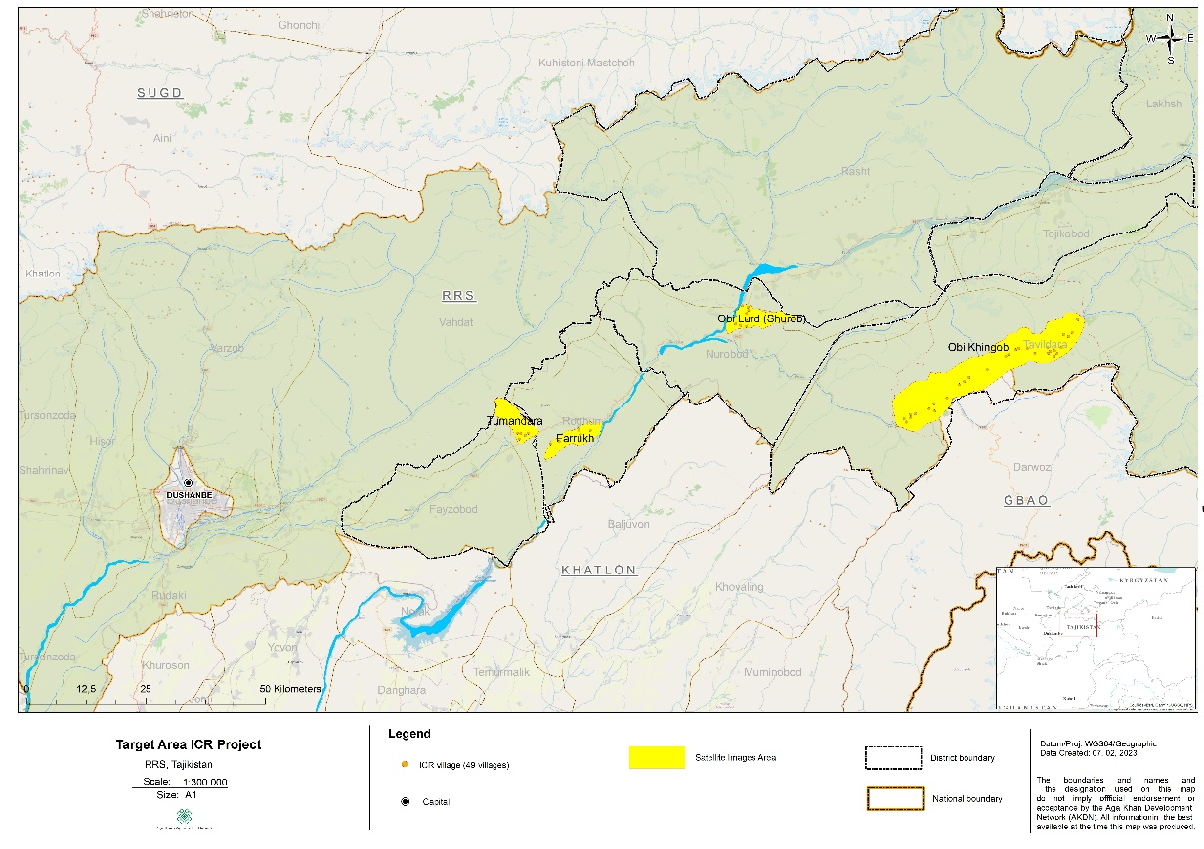

Map1. Are of interest.

AKAH is looking for a satellite images provider to deliver 5 or fewer meter resolution images (with 7 years gap between each) for the 4 watersheds (polygons will be provided).

The characteristic of the satellite images is shown below.

# Characteristics of the satellite images

* Resolution: 5 meters or less
* Product Level: Orthorectified and mosaiced
* Cloud coverage: < 5%
* Off Nadir Angle: < 25 °
* Date: May, beginning of August months, 3 different years from 2000 to 2022
* Spectral Bands: 4 bands (R, G, B, NIR)
* RMS: better than 7m
* Bit depth: 12bits
* Projection: UTM 42N, WGS84
* Image Format: GeoTIFF
* Area: >440 km2
* The satellite image product used for this project must be of European or American Origin

**Proposals should be sent to the email address:** amiraidar.ghulomaidarov@akdn.org

**Only shortlisted candidates will be contacted.**