Khorog Urban Resilience Programme

Planning and Proof of Concept Initiative

TERMS OF REFERENCE

Disaster Risk Reduction Consultancy

February 2023

Position: Disaster Risk Reduction (DRR) Consultancy Services
Organization: Aga Khan Agency for Habitat – Khorog Urban Resilience Programme
Location: Tajikistan, GBAO, Khorog
Duration: One Year

Context

The city of Khorog is the administrative center of the Gorno-Badakhshan Autonomous Region located at an altitude of 2100m above the sea in the eastern part of Tajikistan. The region is in a zone of high seismic and tectonic activity. Apart from earthquakes, other natural geological processes are widely developed. Among them, landslides, rockfalls, mudflows, avalanches, and flooding stand out. Snow avalanches, rockfalls, and landslides pose the greatest threat.

The city has a population of around 30,000 people and an annual growth rate of 1%. As the city is surrounded by high mountains and there is a lack of space for other infrastructure, housing, and agriculture development, people have no other choice than to use hazardous zones. This is mainly caused by the lack of well-developed policies in the city planning and awareness of climate-related challenges, which makes the city vulnerable to the most common natural hazards. Although natural hazards cannot be entirely prevented, their effect on people can be reduced through Disaster Risk Reduction strategies.

In 2020, the Aga Khan Agency for Habitat (AKAH), with the financial support of the State Secretariat for Economic Affairs (SECO) of the Swiss Government, initiated Khorog Urban Resilience Programme (KURP). The program contributes to the 17 Sustainable Development Goals, especially the SDG6, SDG11 and SDG13, and one of the main components of the program is Making Cities Resilient 2030 (MCR2030) campaign initiated by the United Nations Office for Disaster Risk Reduction (UNDRR), which Khorog city is joining.

As part of the Khorog Urban Resilience Program (KURP), in 2020, the Aga Khan Agency for Habitat assessed the risks of natural hazards in the city of Khorog. As a result of the assessment, 2,156 households, and 661 social facilities and infrastructures are at increased threat of natural hazards (Map 1). Assessments carried out for the period 2015 to 2021 showed that, along with local threats, there are high degrees of risks for the city of Khorog from distant natural hazards occurring at a considerable distance from the city of Khorog, which can have a rather dangerous impact on large areas. For example, the overlap of the river valley Gunt in ​​the village of Barsem by a glacial mudflow followed by the formation of a dammed lake with a water volume of more than 1 million m³.
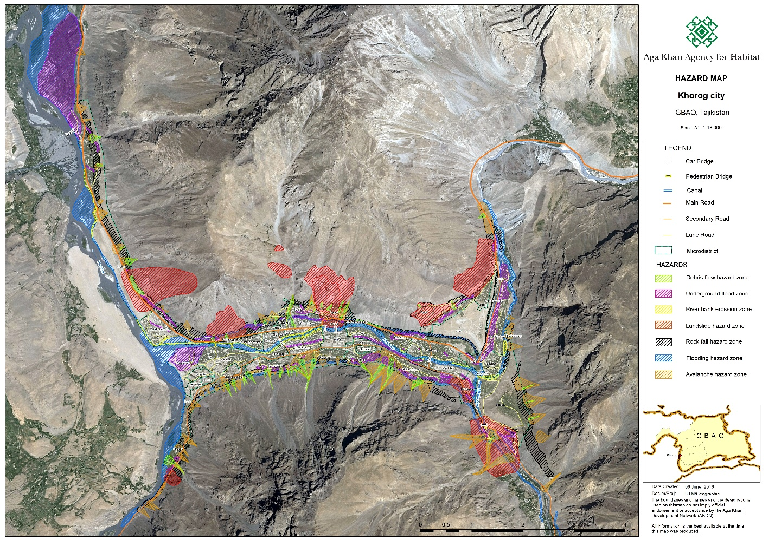
Map 1. Khorog Hazard Map

To make the city of Khorog resilient to natural hazards, the Aga Khan Agency for Habitat is hiring an experienced international consultancy company in disaster risk reduction. Companies with relevant expertise in this field are highly encouraged to apply.

Responsibilities

The consultants will work under the KURP and report to the head of the Operational Research and Technical Department of AKAH. The experts will be in close collaboration with Main Department of Geology and the Committee of Emergency Situations. Main goals include using remote sensing techniques to do modeling of avalanche, rockfall, landslide and understand their impact on communities and propose mitigation measures to reduce the impact. Also capacity building and trainings are essential part of the consultancy service. Main activities include:

Hazards and Risk Vulnerability Assessment:
  - Modeling potential impact of avalanche, rockfall, landslide for Khorog;
  - Performing risk evaluation and identifying practical solutions to prevent them.
  - Validation of existing assessment results and cross validation with remote sensing and modelling results.
  - Assessment of legislation and policy frameworks, identifying challenges and constraints and provision of recommendations on requirements to fill existing gaps
  - in consultation with the AKAH team, propose improved tools, approaches and methodology, which may include modelling for multi-hazard disaster risk assessment with guidelines for implementation;

Mitigation assessment:
  - Identifying and prioritizing areas with high environmental risk.
  - Providing appropriate mitigation measures depending on the type of hazards.
  - Conducting remote sensing analysis of potential hazard zone and comparing and validating with field assessment of hazards.
  - Providing cost estimation for small to big mitigation project with their design.

Climate change impact and adaptation:
  - Assessing the potential risk caused by climate change.
  - Finding measures to adapt to climate change impacts based on provided information.
  - Developing a framework for assessing vulnerability to climate change.

Conducting training and capacity building session on:
  - Hazard and risk assessment methodologies.
  - Climate Change adaptation.
  - Identification of potential hazards zone using remote sensing techniques specifically:
    - Hazard modeling using remote sensing for avalanches and rockfalls and landslide.
    - Complex mitigation recommendations development
    - Interpolation of satellite images for hazard detection using remote sensing.
  - Spatial analysis and advanced cartography.
  - Mitigation project development.

Recommended Experts

DRR Consultant - conducting DRR assessment at National, Regional, Khorog City (focus area) levels. Reviewing and recommending policies and procedures for mainstreaming DRR. Preferably experts in rockfall, avalanche and landslide (Or include separate experts for each hazard type).
Civil Engineer – designing mitigation projects based on the DRR consultant’s recommendations.
GIS and cartography Expert - spatial analysis, advanced mapping, and data visualization.

Qualification required/Selection criteria

- A minimum of 10 years of experience in disaster risk assessment and mitigation.
- Consisting of a team of DRR specialist with a knowledge of complex spatial analysis. Who has an experience in developing similar analytical tools as a decision support system as well as computer programmer to enhance the Geoportal.
- Experience of working with local and international development organizations.
- Have an experience of working within urban areas and urban planning specific projects.
- Ability to work within a strong framework of processes and procedures.
- Maturity and professional ability to handle sensitive information and ability to respect the confidentiality of such information over the course of the work, as well as after the expiry of the contract.
- Geoscience knowledge of complex spatial analysis.
- Demonstration of a quality in performing the services that would include brochures, description of similar assignments, experience in similar conditions, and availability of appropriate skills.
- Demonstration in understanding of disaster and climate vulnerabilities and understanding the impact of climate change impact on community
- Demonstration of experience in writing easily understood reports that include explicit recommendations for action
- Demonstration of knowledge of Geographical Information Systems and Remote Sensing is crucial.

Evaluation Criteria

Phase 1: Technical Evaluation
The evaluation of the technical part of the proposal will be on the basis of the service provider’s responsiveness to the terms of reference, as well as the application of the evaluation criteria and points system as indicated below. Each responsive proposal will be given a technical score.
Evaluation Criteria – total 100 points

Technical Criteria | Points Allocated
The company’s quality of work delivered through different projects | 15 %
Experience and qualifications of the team and company. This part of the evaluation will be based on the CVs of the team developing the system that needs to be shared by the firm in their proposal. The number of team members is not as important as the relevance of the staff to perform the task | 15 %
The approach and methodology for the proposed assignment | 15 %
Previous experience in working with similar assignment | 15 %
Geotechnical knowledge and understanding of the context and task at hand | 10 %
Evaluation of the proposal, innovative solutions | 10 %
Track record on Disaster Risk Reduction consultancy services | 10%
Approach to capacity building and trainings | 10%
TOTAL | 100

Phase 2: Pricing Evaluation
Proposals that are shortlisted for further consideration based on the above criteria will
consequently, be evaluated based on a mix of technical and financial criteria. The
following criteria will be used for the evaluation of the proposals:

  - Pricing 100 points

Submission details

Applications should be sent to the email address: navruzsho.avzalshoev@akdn.org and sardor.mohiev@akdn.org , or submitted to the offices of Aga Khan Agency of Habitat at the following address: 34 Rudaki Avenue (TCELL plaza, 10th floor), Dushanbe, Tajikistan.

